Delicious Home Made Treats.

Take Them
Home to Enjoy for Di-nner

Oct. 25 9AM-SPM
Oct. 26 9AM-4PM

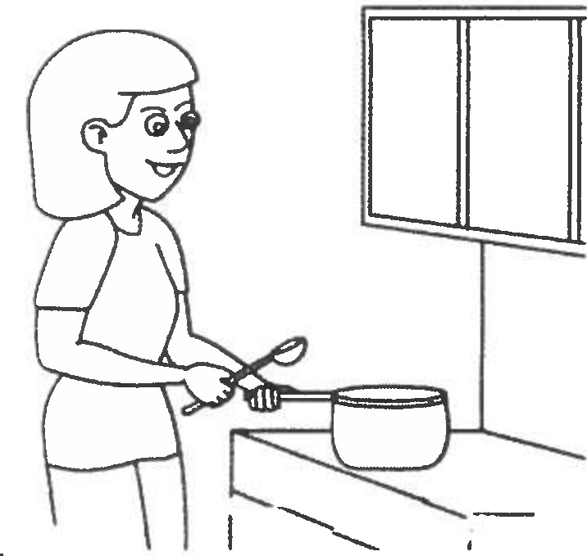Far Right Corner. Next to Kitchen Of PLC

'J::

Chicken Corn Chowder with Bacon
A rich creamy soup filled with pulled chicken, corn, carrots, celery and bacon. All this is seasoned to perfection, and definitely homemade. 32 oz.
$7.

Chili

A thick, hearty soup made with Fresh Market ground chuck, tomatoes, onions, peppers, kidney beans, and just the right amount of season-
ings. Totally homemade with a mild/medium heat. 32 oz. $8.
New England Clam Chowder

Delicious soup packed with tender minced clams and pota­ toes and smoothed out with a lively balance of butter and milk. 32 oz. $7.
Stuffed Green Pepper Soup

Everything you love about stuffed peppers - bell pepper, ground beef, tomatoes and rice in a hearty sou p. 32 oz.
$7.
Chicken Divan

Fresh broccoli and chicken bake in a savory sauce topped with a rich, cheesy t opping. Serves 4. $12.
Single serve $4.

Cheese and Spinach Quiche

A savory dish consisting of pastry crust filled with eggs, milk with cheese and spinach Large $15 Small $6

Eggplant Parmesan

Fresh eggplant lightly breaded, fried and baked in a homemade marinara sauce, with Italian cheeses tucked be­ tween layers. Absolutely the best!
Serves 4. $12.

Meatballs In Marinara Sauce

Meatballs made with ground chuck, lean ground pork, a few bread crumbs, herbs and seasonings. These are cov­ ered with a homemade marinara sauce which has been simmered to perfection. Six large meatballs with plenty of sauce $12.
Chicken Pot Pie

Homemade chicken pot pie with flaky pie crust and creamy chicken pot pie filling. Classic comfort food! Serves 4
$12. Single serve $5.

Cheese and Bacon Quiche

A savory dish consisting of pastry crust filled with eggs, milk with bacon and cheese Large $15 Small $6

Turkey Tetrazzini

Lots of pulled turkey breast, in a creamy, cheesy sauce with peas, mushrooms and just a hint of sherry. All this is added to a little spaghetti and topped with parmesan bread crumbs. Serves 4 generously. $12. Single serve $5.

Shepherd's Pie

Ground Beef with vegetables in a rich gravy, topped with cheesy mashed po­ tatoes, and baked. Serves 4. $12. Sin­ gle serve $4.
Jams

Blueberry, Fig and Strawberry Fruit Preserves and Apple Butter. 8 oz.. $8 and 4oz. $4.
Boursin Cheese

A fresh spread of soft cheese and butter flavored with herbs and spices. A great appetizer! 8 oz.. $5.
Chicken Salad

Pulled chicken breast, with dried cranberries, diced celery, mayo and just the right season­ ings. 16 oz. carton $7.

Cocktail Crackers

Tasty appetizer cracker 4 oz. package $4.

Scalloped Potatoes

Sliced russet potatoes in a creamy cheese sauce. Totally homemade, and delicious. Sin­ gle serve $4. Large pan serves four generously $8.

