The Customs and Liturgies of Holy Week
The Triduum and Easter Sunday

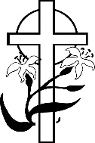

The Great Easter Vigil
8:00 PM - streamed

Holiday Schedule

At nightfall on Holy Saturday, the blessed Sabbath is over. The first day of the week begins. After the Sabbath, according to custom, the first work to be done is to make a fire and to kindle the evening lamp. That is what the Church does. That is how the Easter Vigil begins.

On this night, every member of the Church is asked to gather with the soon-to-be-baptized. We keep watch together. We settle down and retell our family stories. St. Augustine said that, on this night above all other nights, the Church keeps watch for the Lord and the Lord keeps watch over the Church!

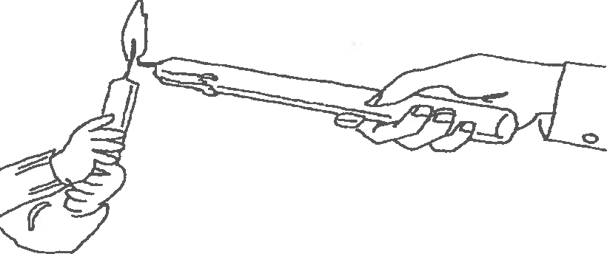

Confession Schedule for Holy Week

There will be opportunities for confessions on
- Wednesday from 10:00 AM – 12 Noon
- Holy Thursday from 10:00 AM – Noon
and 1:00 – 3:00 PM

Easter Sunday Masses

8:00 AM
10:00 AM - streamed,
no incense
12:00 PM

(Easter Baskets available
at all Sunday Masses)

THERE WILL BE NO DAYTIME ADORATION IN OUR EUCHARISTIC CHAPEL ON HOLY THURSDAY
Nightwatch begins in the main chapel after Holy Thursday Mass

The parish office will be closed starting at noon Good Friday, through Easter Monday.

Precious Blood of Christ is a wonderful place of worship -
Would you like to know more about our ministries? Interested in getting involved? Part-time or full-time residents are valued and welcomed. Please register with us.

You can register at our church office or visit our wonderful website at:

www.pbocchurch.com

The Customs and Liturgies of Holy Week
The Triduum and Easter Sunday

Holy Thursday
The Liturgy
6:00 PM - streamed

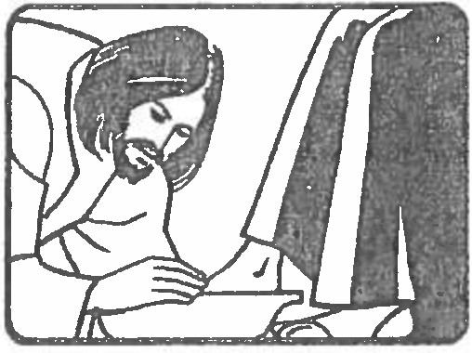
Lent ends at sundown and

Follow Jesus
Good Friday

Stations of the Cross
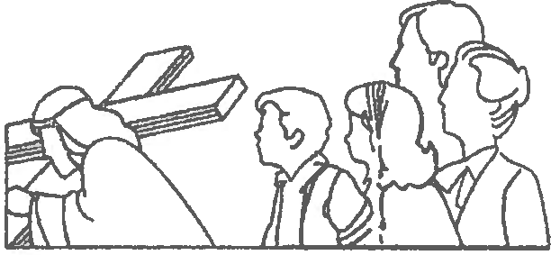
12:00 Noon

the Paschal Triduum begins.
The Gospel of John tells us
that Jesus, while he was at
supper, got up and washed
the feet of his disciples. In
the Middle East, where
people's feet easily became dusty, and before the days of convenient plumbing, this washing was an act of hospitality. Rich people usually had servants to perform this service, so the apostle Peter was embarrassed and told Jesus not to do it. But Jesus warned Peter, "Unless I wash you, you can have no share with me." Then Jesus said, "I have given you an example. You should do for each other what I have done for you."

During tonight’s liturgy, in accord with the Gospel mandate, we will have the opportunity to rededicate ourselves to ministerial service in a very meaningful and symbolic way.

After celebrating the Eucharist and sharing Communion, we will carry the consecrated elements out of church in a solemn procession. Nightwatch begins!

Nightwatch

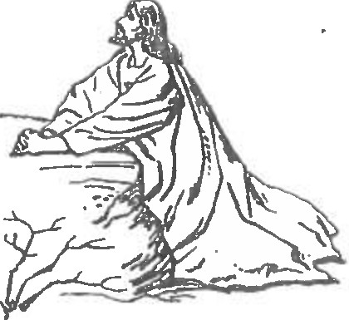
The Eucharist is placed in repose. Tonight, Jesus asks each of us to keep watch with him as he did with his disciples in the Garden of Gethsemane so long ago. Please plan to spend some time with Him this evening. The church will remain open until midnight.
through the streets of Jerusalem. Are we among those who lurk in the shadows, or with the few who accompany him on the journey? There will be traditional stations at 12 Noon.

Liturgy of the Passion
3:00 PM - streamed

This day is part of something bigger than itself. The liturgies of Good Friday have no formal beginnings or endings, no greetings or dismissals. The services are all part of the single, three-day liturgy of the Triduum. The Eucharist is not celebrated. The Passion in John's Gospel shows us how God's glory is seen in the suffering and death of Jesus. In this service, everyone will participate in carrying the Cross, that we might experience its burden and reverence its sweetness!

Tenebrae
7:00 PM

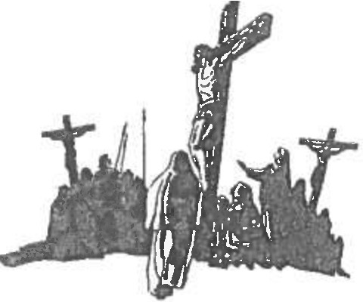
"God of day and God of darkness, we stand before the night. As the shadows stretch and deepen, come, make our darkness bright!" "Tenebrae" is a Latin word, meaning darkness and shadows. It is comprised of selections from the Psalms and the Book of Lamentations, which are accompanied by the extinguishing of candles and the dimming of lights. It has a surprise ending. Don't miss it!

